- First Normal Form
1NF
(EMP_NUM, EMP_LNAME, EMP_DOB , EMP_HIRE_DATE, EMP_EDUCATION, EMP_TRAINING , EMP_TITLE, DEPT_CODE, DEPT_NAME, DEPT_MANAGER, JOB_CLASS, EMP_BASE_SALARY, EMP_COMMISSION_RATE)
Partial Dependencies:
(EMP_NUM EMP_EDUCATION, EMP_TRAINING, EMP_DOB , EMP_HIRE_DATE, EMP_TITLE )
(EMP_LNAME EMP_DEPENDENTS )
( EMP_TITLE DEPT_CODE, DEPT_NAME, DEPT_MANAGER )
Transitive Dependency:
( JOB_CLASS EMP_COMMISSION_RATE EMP_BASE_SALARY )
- Second Normal Form
2NF
EMPLOYEE (EMP_NUM, EMP_LNAME, EMP_DOB , EMP_HIRE_DATE, EMP_EDUCATION, EMP_TRAINING , EMP_TITLE)
EDUCATION ( EMP_NUM, EMP_EDUCATION)
DEPENDANTS ( EMP_LNAME, EMP_DEPENDENTS )
DEPARTMENT (EMP_TITLE, DEPT_CODE, DEPT_NAME, DEPT_MANAGER)
TRAINING ( EMP_NUM, EMP_TRAINING)
Transitive Dependency
JOB_CLASS EMP_COMMISSION_RATE EMP_BASE_SALARY

- Third Normal Form
3NF
EMPLOYEE (EMP_NUM, EMP_LNAME, EMP_DOB , EMP_HIRE_DATE, EMP_EDUCATION, EMP_TRAINING , EMP_TITLE)
EDUCATION ( EMP_NUM, EMP_EDUCATION)
DEPENDANTS ( EMP_LNAME, EMP_DEPENDENTS )
DEPARTMENT (EMP_TITLE, DEPT_CODE, DEPT_NAME, DEPT_MANAGER)
TRAINING ( EMP_NUM, EMP_TRAINING)
COMMISION ( JOB_CLASS , EMP_COMMISSION_RATE)
Dependency Diagram
- 1ST NORMAL FORM
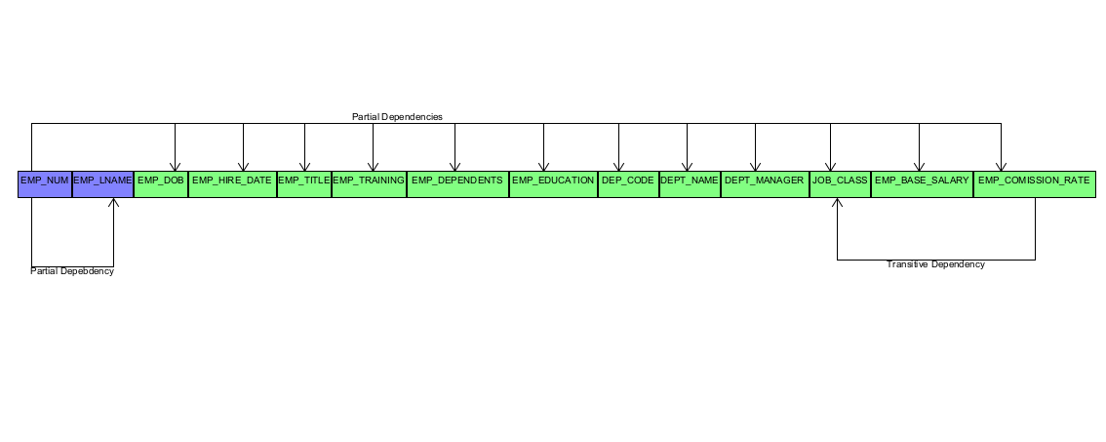

Dependency Diagram
- 2nd NORMAL FORM

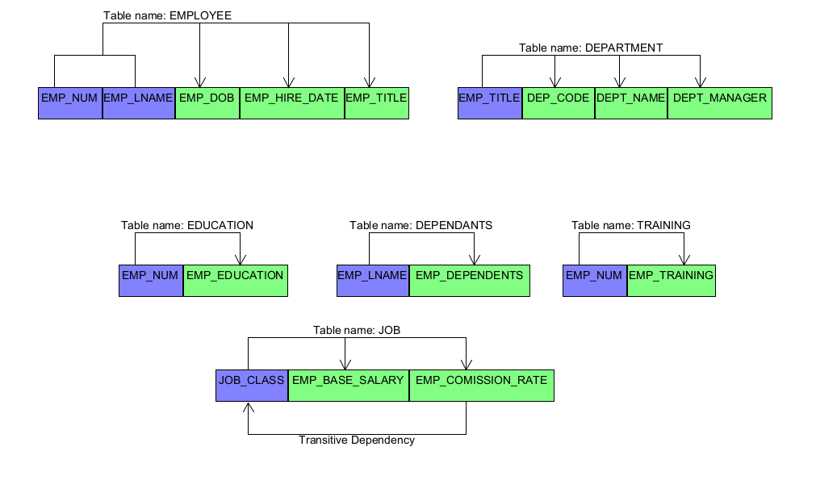

Dependency Diagram
- 3rd NORMAL FORM

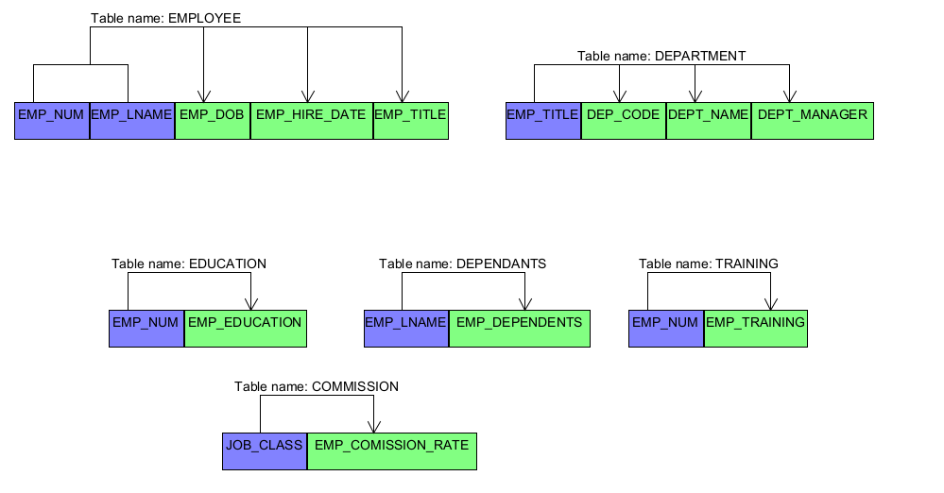
EMPLOYEE
EMP_NUM | EMP_LNAME | EMP_DOB | EMP_HIRE_DATE | EMP_TITLE
1003 | Willaker | 20-Jul-1959 | 15-Jul-1999 | Sales Agent
1018 | Smith | 18-May-1982 | 21-Apr-2003 | Sales Agent
1019 | McGuire | 28-Mar-1979 | 15-Jan-2006 | Janitor
1023 | McGuire | 23-Dec-1968 | 14-Oct-1997 | DB Admin

EDUCATION
EMP_NUM | EMP_EDUCATION
1003 | BBA
1003 | MBA
1018 | BBA
1023 | BS
1023 | MS
1023 | Ph.D.

DEPENDANTS
EMP_LNAME | EMP_DEPENDENTS
Willaker | Gerald (spouse)
Willaker | Mary (daughter)
Willaker | John (son)
McGuire | JoAnne (spouse)
McGuire | George (spouse)
McGuire | Jill (daughter)

EMP_TITLE | DEPT_CODE | DEPT_NAME | DEPT_MANAGER
Sales Agent | MKTG | Marketing | Jill H. Martin
Sales Agent | MKTG | Marketing | Jill H. Martin
Janitor | SVC | General Service | Hank B. Jones
DB Admin | INFS | Info. Systems | Carlos G. Ortez
DEPARTMENT

EMP_NUM | EMP_TRAINING
1003 | L1
1003 | L2
1019 | L1
1023 | L1
1023 | L3
1023 | L8
1023 | L15
TRAINING

JOB
JOB_CLASS | EMP_BASE_SALARY | EMP_COMISSION_RATE
DBS | R127,900.00 | 0.00
JNT | R19.750.00 | 0.00
SLS | R30,500.00 | 0.010
SLS | R38,255.00 | 0.015

COMMISSION
JOB_CLASS | EMP_COMISSION_RATE
DBS | 0.00
JNT | 0.00
SLS | 0.010
SLS | 0.015

